TFS #92339

2016 Tax Season IRS Requirements for Real Estate Collateral

Kevin Geissler

10/17/2016

Table of Contents

TFS # 1

Description 2

Testing Notes 2

Screen Shots and Steps Taken 2

# Description

The IRS is looking for additional information this year. We'll need to pull the information from boxes 7,8,9 from CW. We can gather the address and location description from existing fields on the location tab, but will need to add a Yes/No dropdown that the user will have to select to indicate if the address of the property is the same as the borrowers MAILING address (not necessarily the borrower's street address)

We will need to display these fields for all associations (some currently have LocationDesc hidden)

The new drop down is mandatory

If the selection is No, then either the address or description will be mandatory as well.

from 1098 instructions, page 4 - <https://www.irs.gov/pub/irs-pdf/i1098.pdf>

|  |  |  |
| --- | --- | --- |
| **Box #** | **Box Title** | **Instructions** |
|  |  |  |
|  |  |  |
| 7 | Is address of property securing mortgage same as PAYER’S/BORROWER’S mailing address? If yes box is checked.  If No, see box 8 or 9, below | If the address of the property securing the mortgage is the same as the payer's/borrower's, the box will be checked and boxes 8 and 9 will be blank. If not, either box 8 or 9 will be completed. |
| 8 | Address of property securing mortgage | This is the address of the property securing the mortgage |
| 9 | If property securing mortgage has no address, below is the description of the property | This is the description of the property securing the mortgage, if box7 is not checked and box 8 is not completed. If the property securing the mortgage has no address, enter the property’s jurisdiction and the property’s Assessor Parcel Number(s) (APN), as indicated in the examples below. Synonyms for the APN include the Assessor’s Identification Number (AIN), the Property Identification Number (PIN), the Property Account Number, and the Tax Account Number. Examples: Washtenaw County, MI VV-WW-XX-YYY-ZZZ |
|  |  |  |

BCM 8/29/16 - Need to make a couple updates:

* Add radio buttons to each Location row. Selected radio button should default to first line entered, but user should be able to manually change this to any of the other lines. This will identify the primary property to be sent to the 1098.
* Change Property Description column header to "Property Description (APN)" - would be nice if this had a tooltip for APN = Assessor Parcel Number
* Remove "Mailing" from "Mailing Addr Same as Property Addr" column header. Change to "Customer Addr Same as Property Addr"

BCM 10/04/16 - Document started and updated. Currently pursuing Option B. Link here: <https://extranet.financialpartners.com/Workspaces/Shared/cwenhance/FPIDocuments/TFS%2089509%20-%202016%20Tax%20Season%20IRS%20Requirements%20for%20Real%20Estate%20Collateral.docx>

BCM 10/06/16 -

Clean up “blank” address rows at Overall and detail levels

Add hyperlink that opens new modal from Location panel for “Set Primary Address for 1098”. This hyperlink can be next to the “Add New Address” hyperlink.

Pulls list of all available addresses from Overall and Detail levels

* Need radio button on this modal to set the primary
* Default radio button to first in list, whether that is from overall or summary doesn’t matter

Change wording for header of existing addresses box: “Select Existing to Link, or Add New Address”

Change “Add Existing Address” hyperlink wording to “Link Existing Address”

When Roper does the data clean-up for existing addresses, needs to set primary address as part of clean up script.

10/14/2016 RMW - Added new required panel called Primary Location. Panel will show a rollup of all summary and detail locations with a radio button to indicate which is the primary location. If a location hasn't already been selected as primary, the first location in the list will be defaulted to primary.

Also modifed wording:

Header for existing addresses list is now "Existing Addresses"

"Link Existing Address" is now "Add Location w/ Selected Address"

"Add New Address" is now "Add Location w/ New Address"

# Testing Notes

## Screen Shots and Steps Taken

The “Locations” tab includes a menu that lists all existing addresses and has an option to “Add Location w/ New Address” with a text field. “Add Location w/ Selected Address” selects the correct address.

The Primary tab selects the first address in the list if a primary address has not been selected. This is changeable and savable.

Submitting or validating a scenario triggers soft errors when selecting a non-valid address in the “Locations” and “Primary Location (1098)” tabs. Scenarios can still be submitted.

---

From the Collateral View screen, I chose a piece of Real Estate collateral and selected “Edit Details” from the dropdown menu.

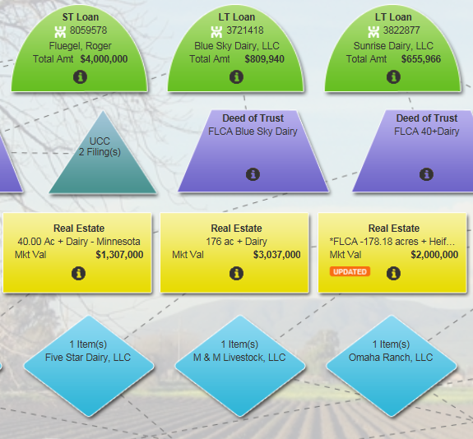

After selecting the “Location(s)” tab, I clicked **“Add Location w/ New Address”** and successfully entered the address below.

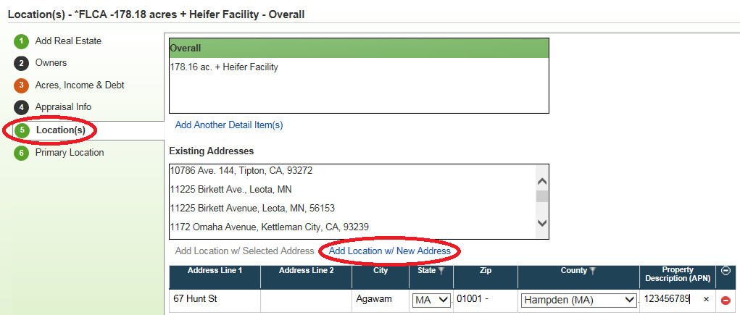

On the “Primary Location” tab, the first address in the list is selected as the primary address by default. The primary address is changeable and savable.

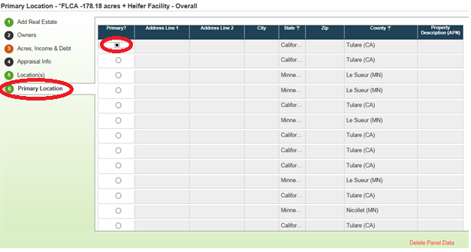

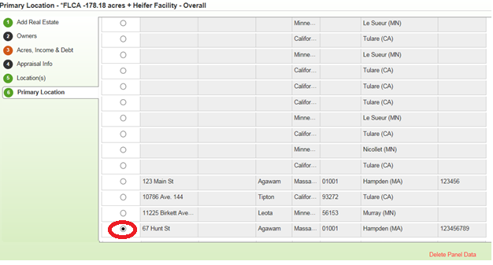

Selecting an address from the “Existing Addresses” menu highlights the address. Choosing **“Add Location w/ Selected Address”** adds the address below. The delete icon deletes the selected address.

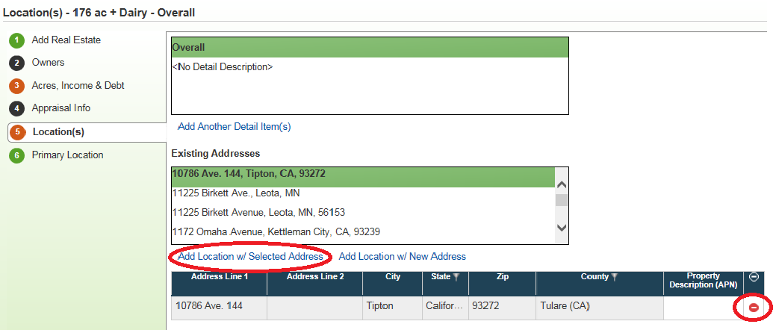

Entering an address that is **NOT valid** will save on the “Location” tab. You can also select an address that is NOT valid on the “Primary Location (1098)” tab. If the scenario is either **validated** or **submitted**, a soft error triggers.

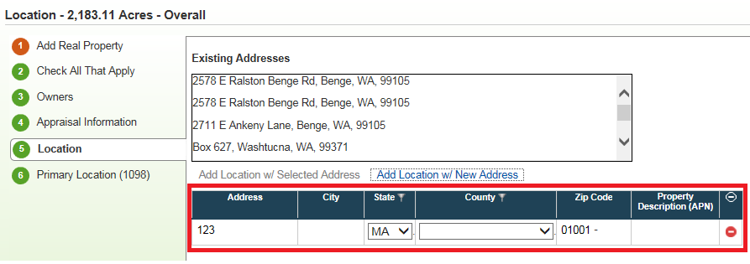

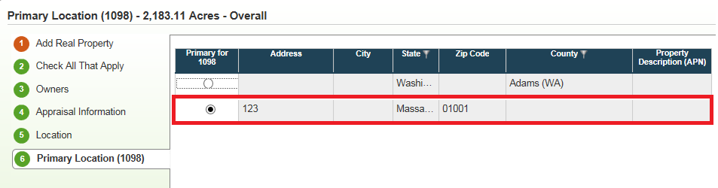

Soft Error 50952 – “Collateral ‘2,183.11 Acres’ Detail: ‘2,183.11 Acres’ requires Add Real Property to be completed” is the error for selecting a non-valid address in the “Location” tab.

Soft Error 51080 – “Valid address information does not exist within the linked Real Property Collateral ‘Bar-U Ranch”. This is required for IRS reporting.” Is the error for selecting a non-valid address in the “Primary Location (1098)” tab.

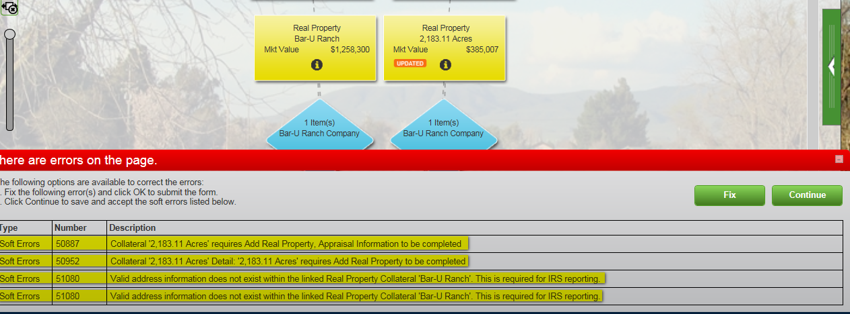

Selecting **“Fix”** closes the error and **brings you back to the scenario.**

Selecting **“Continue”** successfully **submits the scenario.**

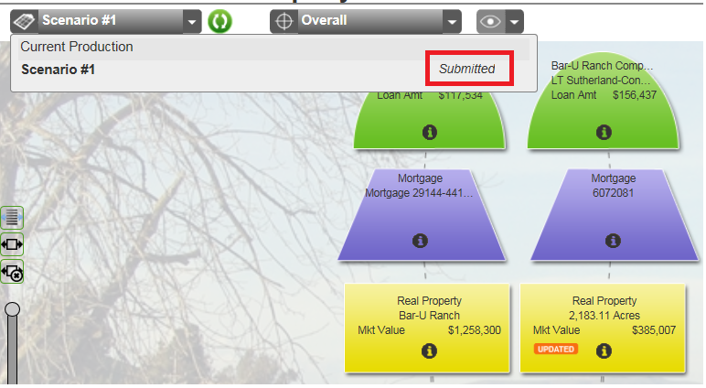

The same errors trigger when a scenario is **validated.**

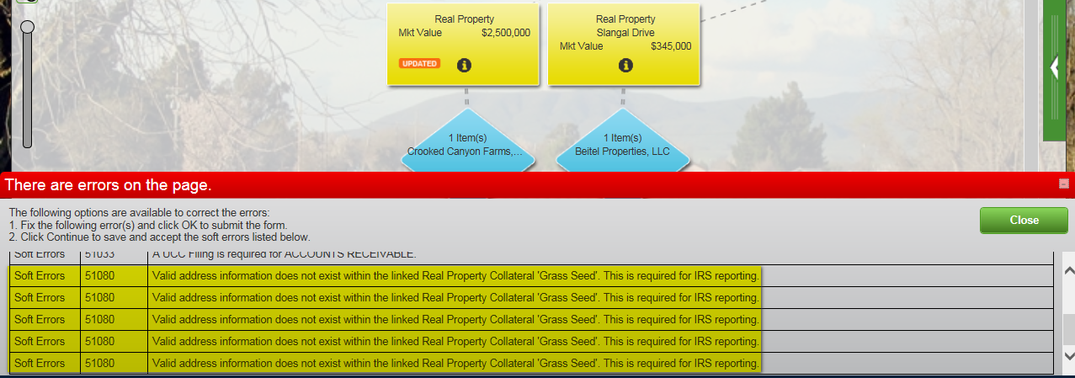

In AgCountry, when **valid addresses are in the “Fixture Location” tab**, but **a valid address is NOT selected in the “Primary Location (1098)” tab**, the soft errors are **not triggering** when **validating** or **submitting**.

